**Physics - Unit 2 - Task 4**

**Laboratory Test**

**Name: Total Marks /40**

**20 minutes Reading and Writing time.**

**20 minutes to Setup and Collect Data from the Experiment**

**20 minutes to Finish the Report**

**Important:**

It is advisable that the Aim, Hypothesis, Prediction, Materials list and Method, plus an Idea on how to record your results be completed before starting your experiments. Also it is recommended that you read all the material on this sheet before beginning.

**Background**

Energy is one of the most important ideas in science. However, energy is an abstract concept, not a substance or an object. One result of this is that energy cannot be completely explained by a single phrase or sentence. Two ways to think about energy are:

* Energy (E) is a quantity that causes change to occur.
* Energy (E) is a measure of an object’s ability to do work.

Kinetic and Potential Energy

When an object moves, it has kinetic energy (Ek). For example, falling rain and a ballerina dancing across the stage both have kinetic energy.

The position or shape of an object determines its potential energy (Ep). For example, a stretched elastic band has elastic potential energy. A lift at the eighth floor has gravitational potential energy.

Kinetic energy and gravitational potential energy are both scalar quantities. You can calculate them using:

**Ek = ½ m v2 and Ep = m g h and t = 1/f**

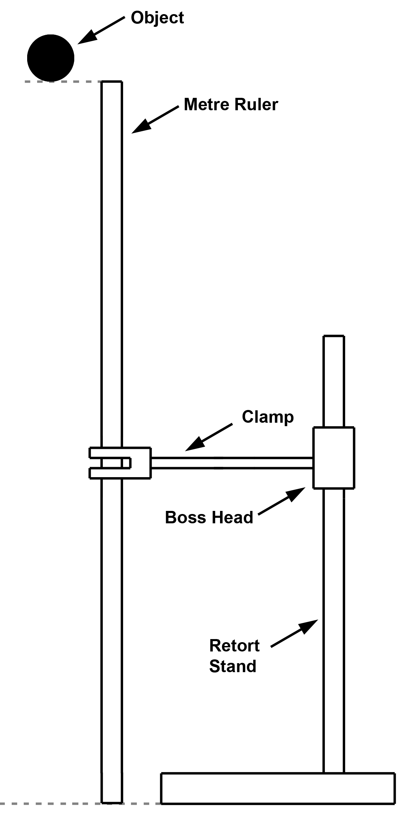 *Figure 1*

where: Ek is kinetic energy in joules (J)

m is mass in kilograms (kg)

v is speed in metres per second (ms-1)

Ep is gravitational potential energy in joules (J)

g is acceleration due to gravity gE = 9.80 (ms-2)

h is height in metres (m)

Energy is neither created nor destroyed and if we assume negligible forms of other energy was created (i.e. heat and sound) we are left with a single relationship; the relationship between kinetic energy and gravitational potential energy. However, in reality there are losses externally.

**Aim**

To investigate the loss of energy when a ball is dropped (energy efficiency).

**Apparatus (per group)**

|  |  |
| --- | --- |
| * metre ruler * ticker-tape * ticker-timer * stop watch * selected object | * sticky tape * power box and required leads * access to a balance * retort stand, boss head, clamp |

**Pre-lab**

* Set up the laboratory experiment as shown.
* Calculate the **“theoretical” kinetic energy** at the point just before contact with the floor.
* Work out how to use the ticker timer tape (attached to the falling object) and measure the final velocity of the falling object. Hence use this information to find the **‘measured’ kinetic energy** at the point just before contact with the floor. Note: the ticker timer runs at 50 Hz.
* Ensure you have planned to mark the start point and finish point of the ticker timer tape.
* For this lab, identify and write down your experimental hypothesis, the dependent variable and the independent variable, and which variables (if any) you intend to control.
* **15 minutes to Setup and Run the Experiment**

**Possible Post-Lab Discussion**

* What have you found out about the experiment?
* What could be discussed in regards to your accuracy and the apparatus’s accuracy.
* Explain how you could use your results in real life cases.

**Conclusion**

Write a conclusion for your lab. You should refer to your original hypothesis, and to the dependent and independent variables.

**Marks Distribution**

|  |  |  |  |  |  |
| --- | --- | --- | --- | --- | --- |
| Section | Marks Available | Marks Received | Section | Marks Available | Marks Received |
| Aim | 1 |  | Method | 2 |  |
| Hypothesis | 4 |  | Results (exc Graph) | 4 |  |
| Prediction | 1 |  | Graph | 8 |  |
| Variables | 3 |  | Discussion | 10 |  |
| Materials list | 2 |  | Conclusion | 5 |  |